# Software Design Description

## Design Overview

* This document describes the technical and user interface design of SWR system. It includes the architectural design, the detailed design of common functions and business functions and the design of database model.
* The architectural design describes the overall architecture of the system and the architecture of each main component and subsystem.
* The detailed design describes static and dynamic structure for each component and functions. It includes class diagrams, class explanations and sequence diagrams for each use cases.
* The database design describes the relationships between entities and details of each entity.
* Document overview:
  + Section 2: gives an overall description of the system architecture design.
  + Section 3: gives component diagrams that describe the connection and integration of the system.
  + Section 4: gives the detail design description, which includes class diagram, class explanation, and sequence diagram to details the application functions.
  + Section 5: describe a fully attributed Entity Relationship Diagram.

## System Architecture Design

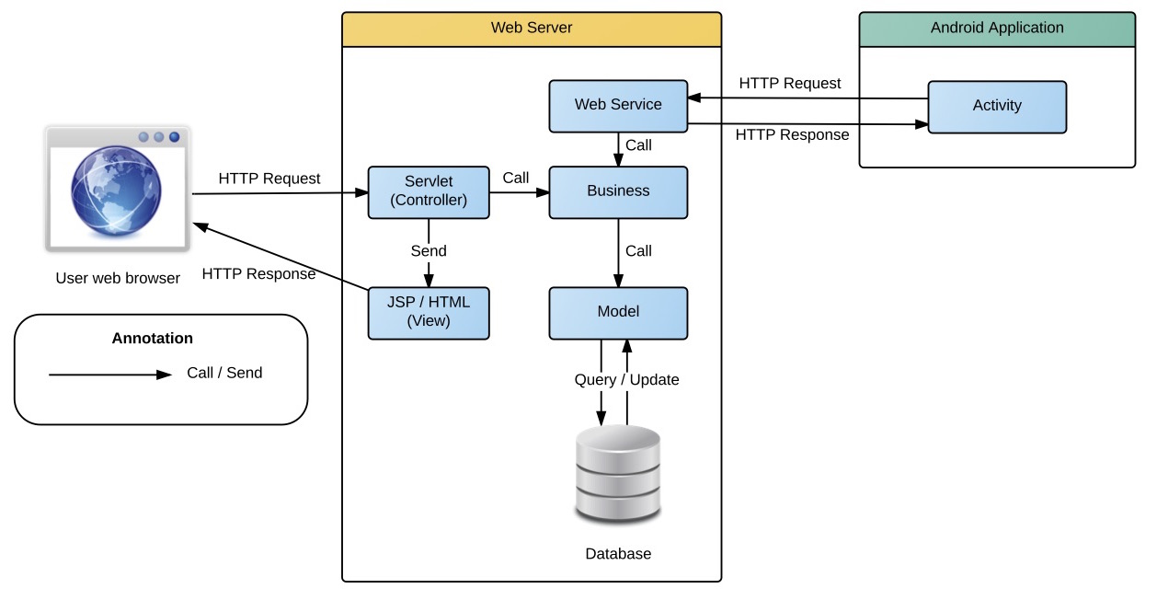

Figure System architecture design

This diagram is referenced and modified from an original concept from: Chapter 6 Architecture Design, SOFTWARE ENGINEERING 9th Edition, by Ian Sommerville.

### Web Application architecture description

In Web Application, the system is developed under J2EE MVC architecture style. We choose this architecture for Web application because of following advantages:

* Web app contains a Web service (public API for mobile app), with MVC architecture, we can separate business code with Controller and View, so we can use the business code in web service without repeat the code.
* Current system only supports motor insurance card, with MVC architecture, we can organize the code better for maintainability, extensibility, reusability so we can expand the scope to other kind of insurance services such as Heath insurance or Asset insurance…
* In scope of 4-member team, MVC architecture make it easier to split the big project into small modules and make it easier to assign each module for members in our team.

This project follows MVC architecture with following components:

* **Servlet (Controller)** is the parts of the application that acts like event handler to handles user interaction. Typically, controller read data from a request and calls appropriate Business’s method then selects view to return to user.
* **JSP/HTML (View)** is the parts of the application that handles the display of the data. The selection of View is under control of Controller.
* **Business** is the parts of the application that do business processing to solve domain problems.
* **Model** is the parts of the application that acts like a data transfer object between the system and database.
* **Web Service** is the parts of the application that acts like event handler for web and mobile communication via REST method.

### Mobile Application architecture description

The application is developed as an Android native application. In general, the application architecture conforms to Android architecture.

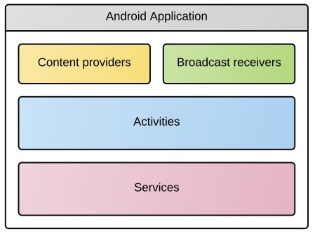

**Reference:** [Android Developer Guide - Application Fundamentals](http://developer.android.com/guide/components/fundamentals.html)

http://developer.android.com/guide/components/fundamentals.html

This project follows Android application architecture with following component:

* **Activity** is the basic core of an android application that handles user input,create thread to run asynchronous tasks, send request and receive data from server via web services ...

## Component Diagram

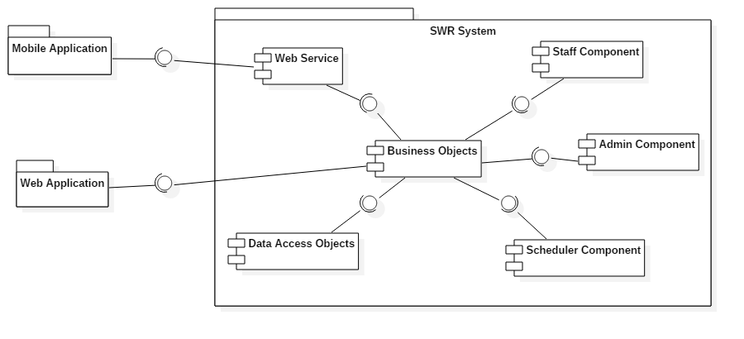

Figure Component Diagram

|  |  |
| --- | --- |
| Component Dictionary: Describes components | |
| Web Application | Web application package: View, Controller |
| Mobile Application | Mobile application package |
| Web Service | operations o handle interaction between the system and database. Provide API for mobile applications to interact with the system. |
| Staff Component | Component to handle staff activities in the system |
| Admin Component | Component to handle admin activities in the system |
| Scheduler Component | Component to handle scheduler in the system |
| Business Objects | Common objects to handle domain business operations for each components |
| Data Access Objects | Component to handle interaction between the system and database |

Table Component Dictionary

## Detailed Description

### Class Diagram

Because web and mobile application need different entities, so conceptual diagram on web will be different to conceptual diagram on mobile application. We decide to design two separated conceptual diagrams.

**4.1.1. Web System class diagram:**

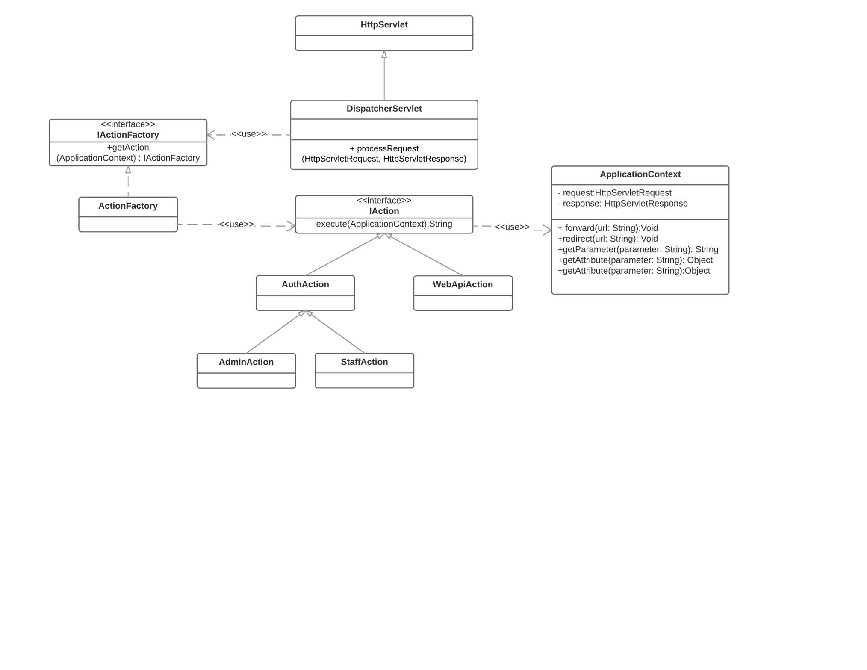

**4.1.1.1. HttpServlet:**

HttpServlet class is a system class of JavaEE framework. HttpServlet is an abstract class to be subclassed to create an HTTP servlet suitable for a Web site.

**4.1.1.2. DispatcherServlet:**

DispatcherServlet is an application class, inherits from HttpServlet and get all requests from client. Base on action string from client, DispatcherServlet will call ActionFactory for getting suitable action for processing.

**4.1.1.3. ApplicationContext**

**4.1.1.4. IActionFactory:**

**4.1.1.5. ActionFactory**

**4.1.1.6. IAction**

**4.1.1.7. AuthAction**

**4.1.1.8. WebApiAction**

**4.1.1.9. AdminAction**

**4.1.1.10. StaffAction**

**4.1.2. Web mobile class diagram:**

Figure Class Diagram

Table Class dictionary

### Class Diagram Explanation

### Interactive Diagram

#### Web Application

##### Staff

**4.3.1.1.1 Parsing source:**

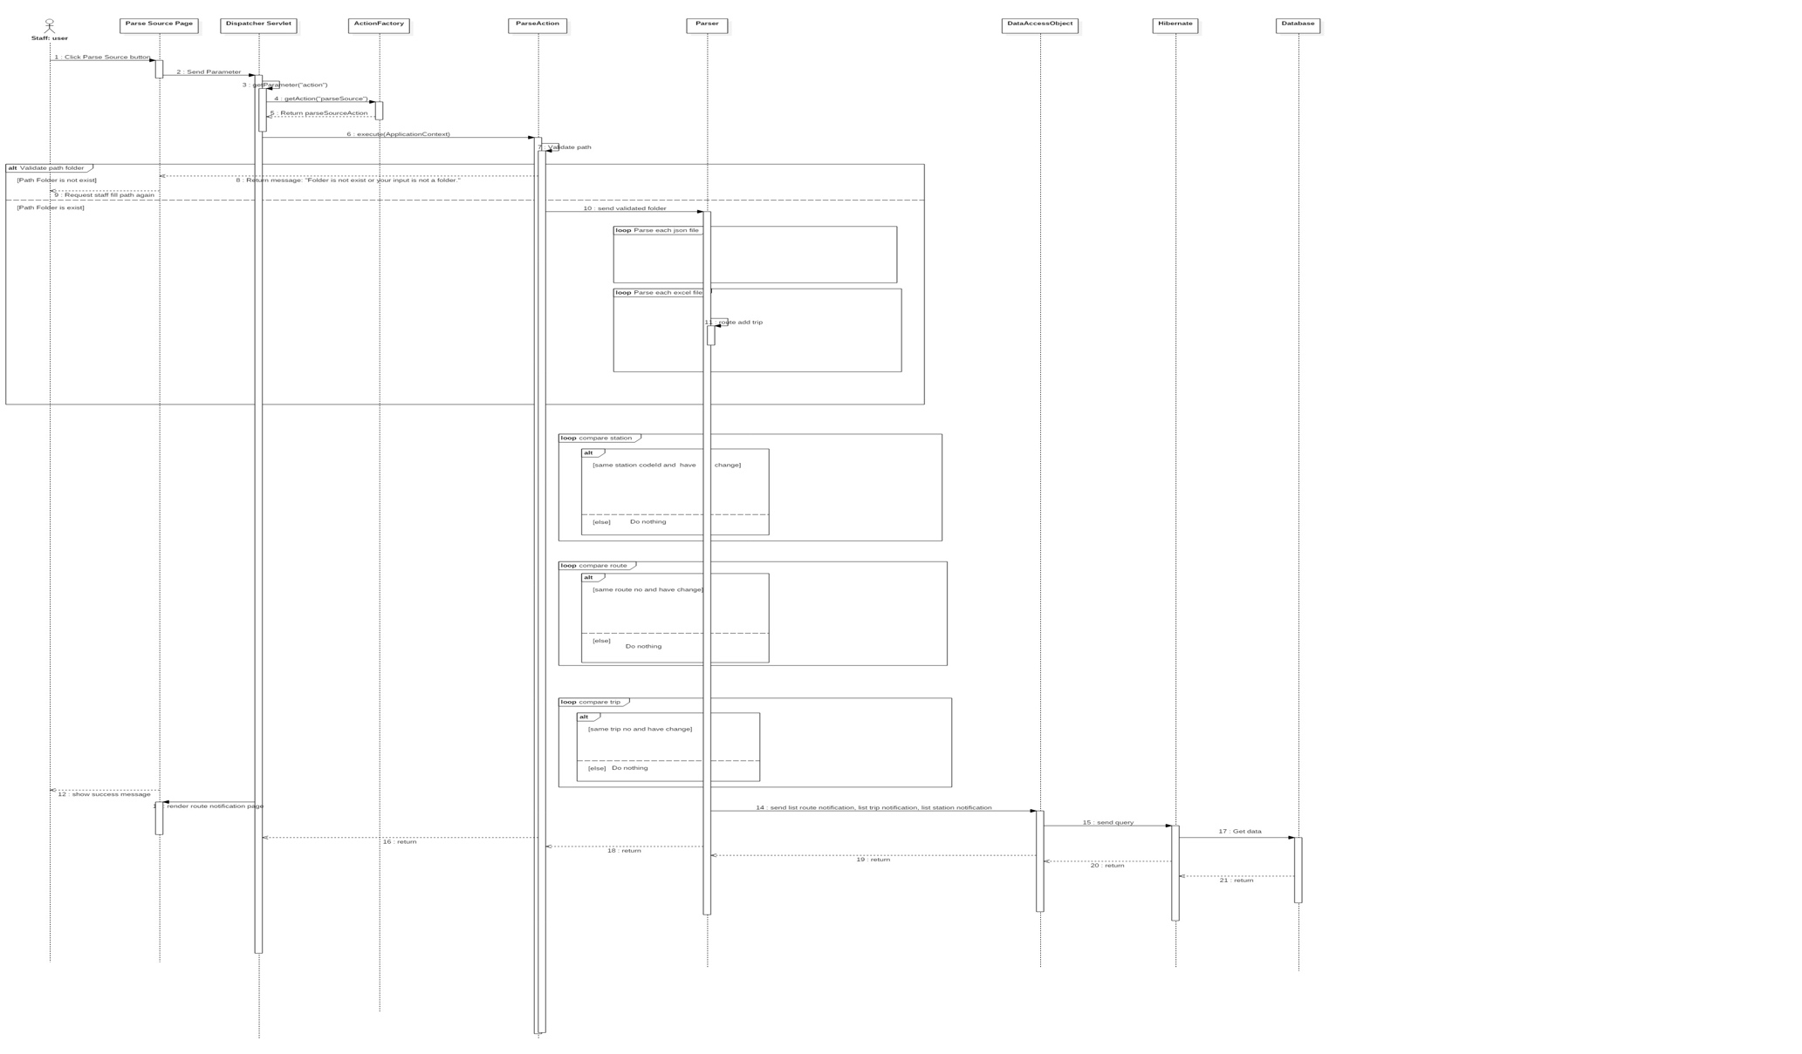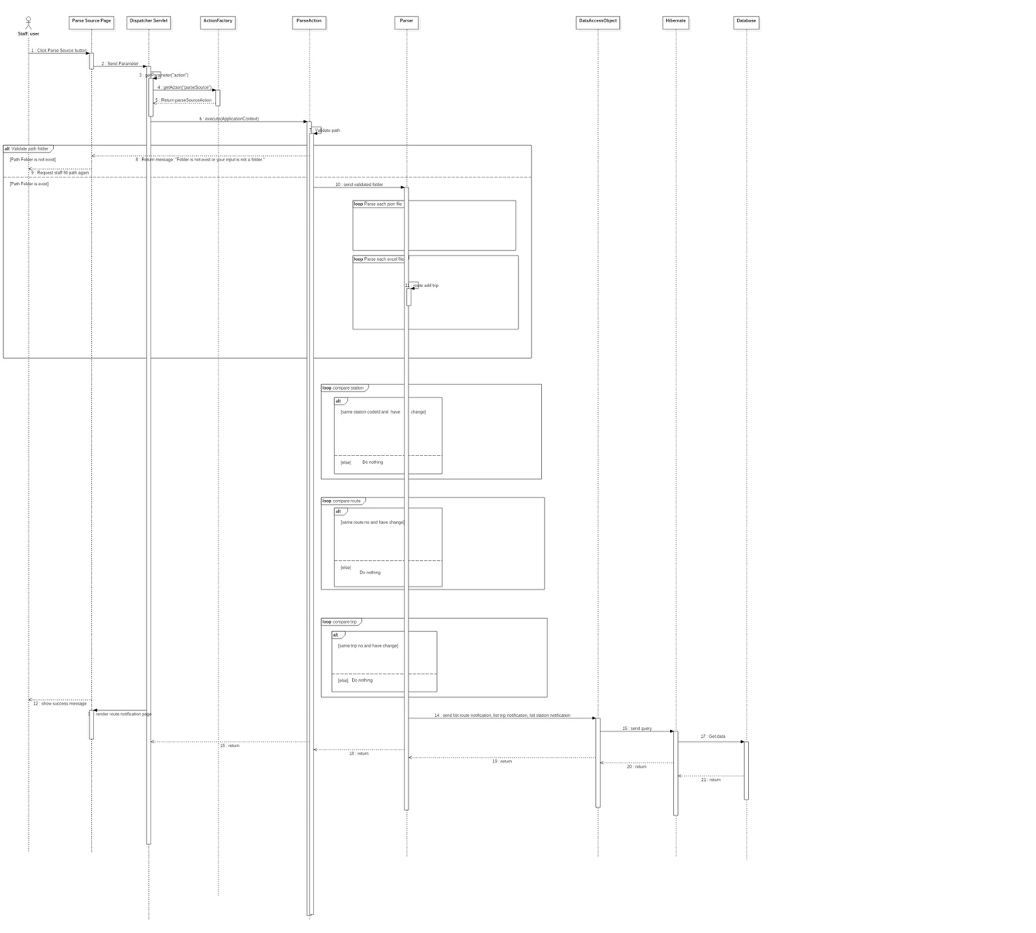

**4.3.1.2. Admin**

#### 4.3.2. Mobile Application

**4.3.2.1. Search Bus Two Point**

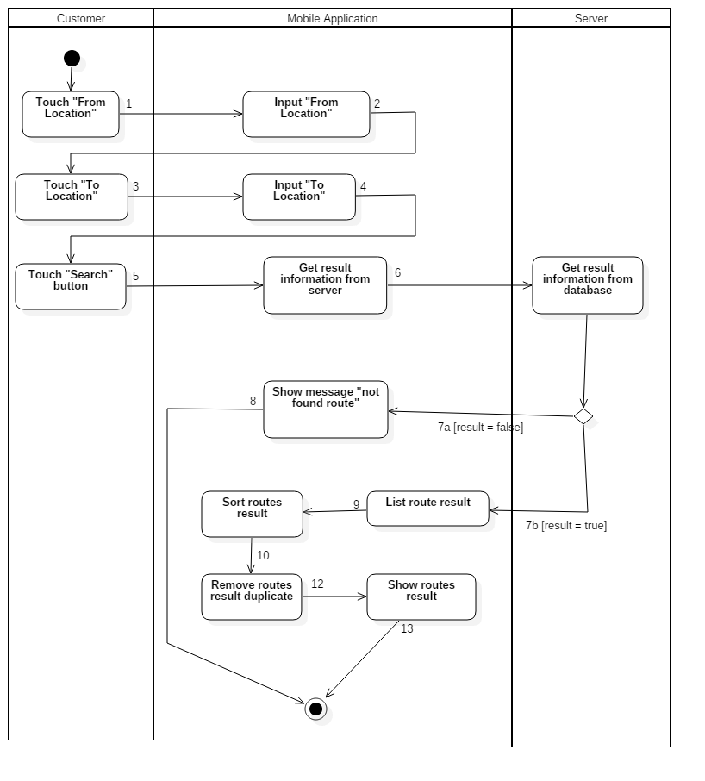

**4.3.2.2. Search Motorbike Two Point**

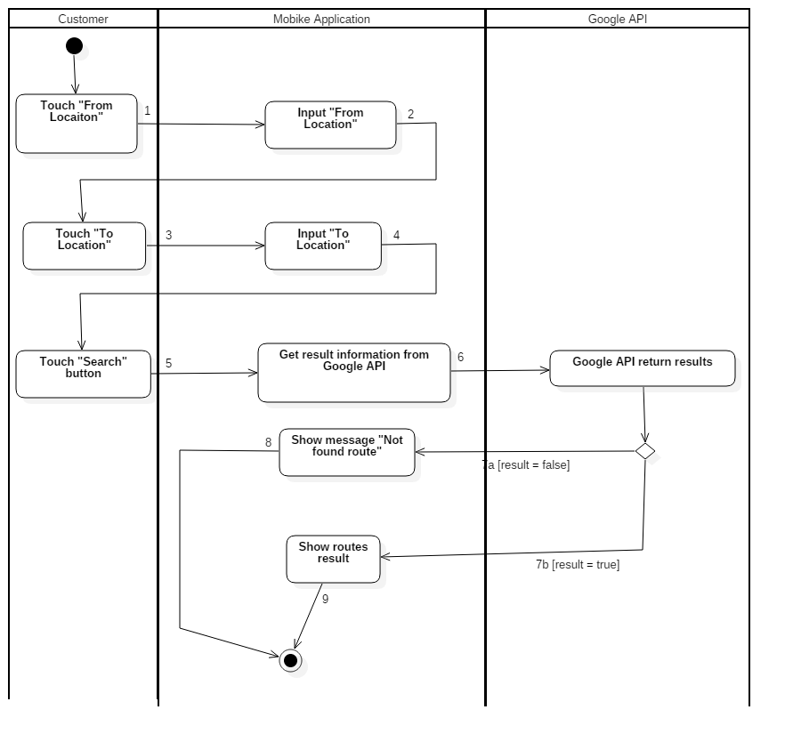

##### 

##### 4.3.2.3. Notify system

##### 

**4.3.3. Wear Application**

## Interface

### Component Interface

#### Web Service Interface

|  |  |  |  |  |  |
| --- | --- | --- | --- | --- | --- |
| Signature | Description | Input | Output | Output Format | Exception |
| public ResponseObject getCheckConnection(R r) | Check server status | Request object r | Json Boolean the status of server | Boolean | JsonProcessingException |
| Contractlean if the update is successntractpublic ResponseObject getContracts(R r) | Search contracts by code or customer name | Request object r contains:  Keyword: String | Json string List of ContractSearchResultDto | ContractEntity  CustomerEntity | JsonProcessingException |
| public ResponseObject getUpdateCardID(R r) | Update card ID to a contract | Request object r contains:  cardID: String  contractCode: String | Json CardEntity object | CardEntity | JsonProcessingException  NoResultException |
| public ResponseObject getCheckCard(R r) | Check the validation of the card | Request object r contains:  cardID: String | Json CardEntity object | CardEntity | JsonProcessingException  NoResultException |
| public ResponseObject getUpdatePunishment(R r) | Update punishment information to a contract | Request object r contains:  contractCode: String  punishmentInfo: PunishmentInfoObject | Json Boolean the update result | Boolean | JsonProcessingException |

Table Web Services Interfaces

|  |  |
| --- | --- |
| Entity | Description |
| ContractEntity | contractCode  startDate  expiredDate  status  contractFee  plate  brand  modelCode  vehicleType  color  engine  chassis  capacity  yearOfManufacture  weight  seatCapacity  cancelDate  cancelReason  cancelNote  staffCode  contractTypeId  customerCode  needRenewPayment  lastModified  createdDate |
| CustomerEntity | customerCode  name  address  email  phone  personalId  password  isDefaultPassword  lastModified |
| CardEntity | cardId  activatedDate  deactivatedDate  contractCode  newCardRequestId |

Table Output format description

|  |  |
| --- | --- |
| Exception | Description |
| JsonProcessingException | encountered when processing (parsing, generating) JSON content that are not pure I/O problems |
| NoResultException | Thrown by the persistence provider when getSingleResult() is executed on a query and there is no result to return |

Table Exception description

### Web application Design

#### Staff Interface Design

##### Staff home page

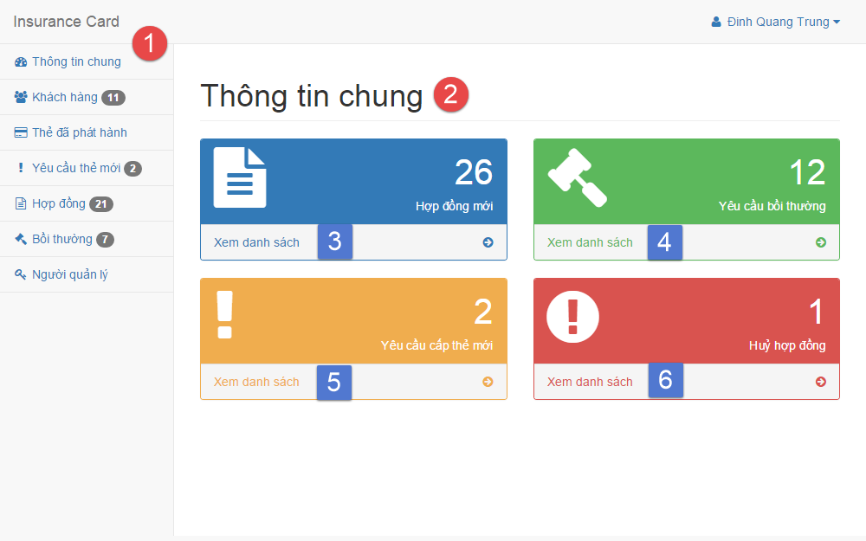

Figure Interface - <Staff> Home page

**Fields**

|  |  |  |  |  |  |  |  |
| --- | --- | --- | --- | --- | --- | --- | --- |
| No | Field Name | Description | Read only | Mandatory | Control Type | Data Type | Length |
| 1 | Menu | Navigation bar | Yes | Yes | Menu bar | N/A | N/A |
| 2 | Title | Title of the page | Yes | Yes | Label | N/A | N/A |

Table Staff home page fields

**Buttons/Hyperlinks**

|  |  |  |  |  |
| --- | --- | --- | --- | --- |
| No | Function | Description | Validation | Outcome |
| 3 | viewContract | List all contract | N/A | Transfer to list contract page |
| 4 | viewCompensation | List all compensation | N/A | Transfer to list compensation page |
| 5 | viewNewCardReq | List all new card request | N/A | Transfer to list new card request page |
| 6 | viewCancelContract | List all cancel contract request | N/A | Transfer to list contract page |

Table Staff home page buttons/hyperlinks

##### Manage customer

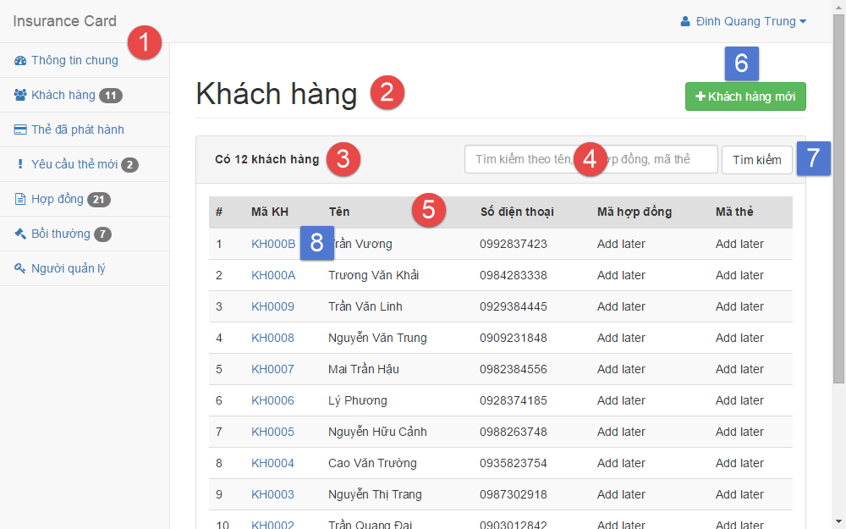

Figure Interface - <Staff> Manage customer

**Fields**

|  |  |  |  |  |  |  |  |
| --- | --- | --- | --- | --- | --- | --- | --- |
| No | Field Name | Description | Read only | Mandatory | Control Type | Data Type | Length |
| 1 | Menu | Navigation bar | Yes | Yes | Menu bar | N/A | N/A |
| 2 | Title | Title of the page | Yes | Yes | Label | N/A | N/A |
| 3 | Number | Number of available customer | Yes | No | Label | N/A | N/A |
| 4 | txtSearchValue | Fill search keyword | No | Yes | Textbox | String | N/A |
| 5 | Table | Table of available customer | Yes | Yes | Table | N/A | N/A |

Table <Staff> Manage customer fields

**Buttons/Hyperlinks**

|  |  |  |  |  |
| --- | --- | --- | --- | --- |
| No | Function | Description | Validation | Outcome |
| 6 | btnCreate | Create new customer | N/A | Transfer to create new customer page |
| 7 | btnSearch | Search by input keyword | N/A | Transfer to search result page |
| 8 | customerDetail | View customer detail | N/A | Transfer to customer detail page |

Table <Staff> Manage customer buttons/hyperlinks

##### Create customer

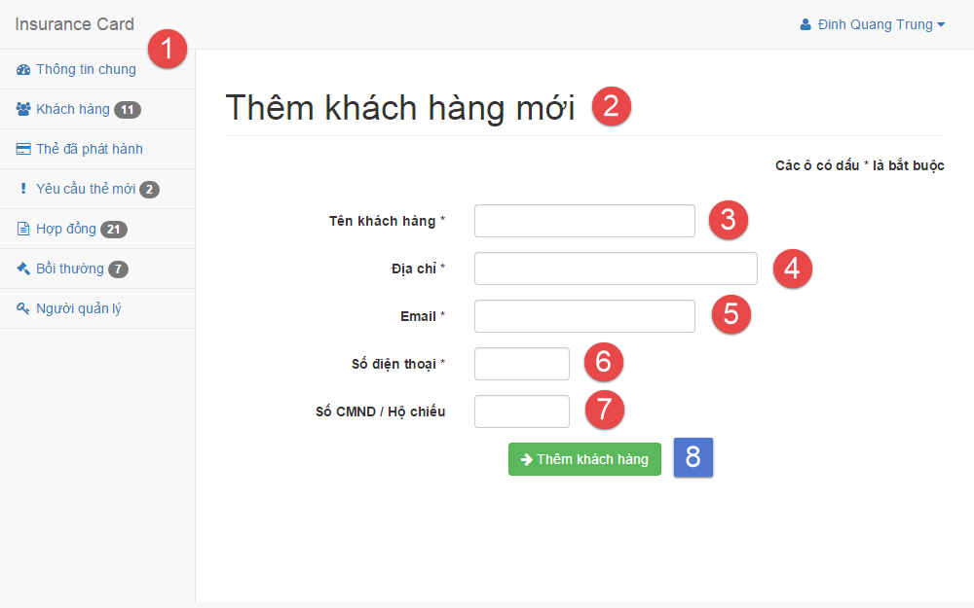

Figure Interface - <Staff> Create customer

**Fields**

|  |  |  |  |  |  |  |  |
| --- | --- | --- | --- | --- | --- | --- | --- |
| No | Field Name | Description | Read only | Mandatory | Control Type | Data Type | Length |
| 1 | Menu | Navigation bar | Yes | Yes | Menu bar | N/A | N/A |
| 2 | Title | Title of the page | Yes | Yes | Label | N/A | N/A |
| 3 | txtName | Fill customer name | No | Yes | Textbox | String | 3 – 80 |
| 4 | txtAddress | Fill address | No | Yes | Textbox | String | 3 – 250 |
| 5 | txtEmail | Fill email | No | Yes | Textbox | String | 3 – 250 |
| 6 | txtPhone | Fill phone | No | Yes | Textbox | Integer | 8 – 15 |
| 7 | txtPersonal ID | Fill personal ID | No | No | Textbox | Integer | 8 – 15 |

Table <Staff> Create customer fields

**Buttons/Hyperlinks**

|  |  |  |  |  |
| --- | --- | --- | --- | --- |
| No | Function | Description | Validation | Outcome |
| 8 | btnCreate | Create new customer | N/A | Transfer to create new customer successful page |

Table <Staff> Create customer buttons/hyperlinks

##### Manage contract

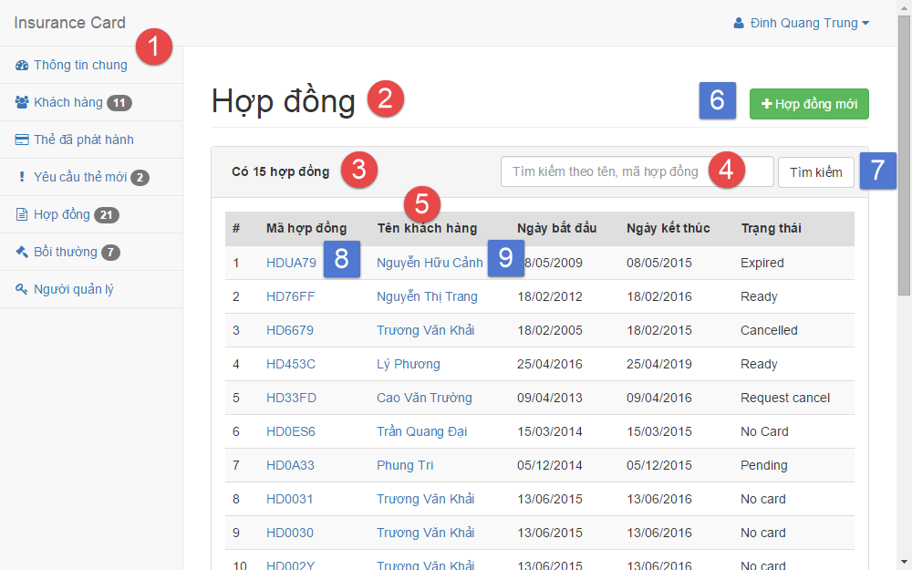

Figure Interface - <Staff> Manage contract

**Fields**

|  |  |  |  |  |  |  |  |
| --- | --- | --- | --- | --- | --- | --- | --- |
| No | Field Name | Description | Read only | Mandatory | Control Type | Data Type | Length |
| 1 | Menu | Navigation bar | Yes | Yes | Menu bar | N/A | N/A |
| 2 | Title | Title of the page | Yes | Yes | Label | N/A | N/A |
| 3 | Number | Number of available contract | Yes | No | Label | N/A | N/A |
| 4 | txtSearchValue | Fill search keyword | No | Yes | Textbox | String | N/A |
| 5 | Table | Table of available customer | Yes | Yes | Table | N/A | N/A |

Table <Staff> Manage contracts fields

**Button/Hyperlinks**

|  |  |  |  |  |
| --- | --- | --- | --- | --- |
| No | Function | Description | Validation | Outcome |
| 6 | btnCreate | Create new contract | N/A | Transfer to create new contract page |
| 7 | btnSearch | Search by input keyword | N/A | Transfer to search result page |
| 8 | contractDetail | View contract detail | N/A | Transfer to contract detail page |
| 9 | customerDetail | View customer detail | N/A | Transfer to customer detail page |

Table <Staff> Manage contracts buttons/hyperlinks

##### Create contract

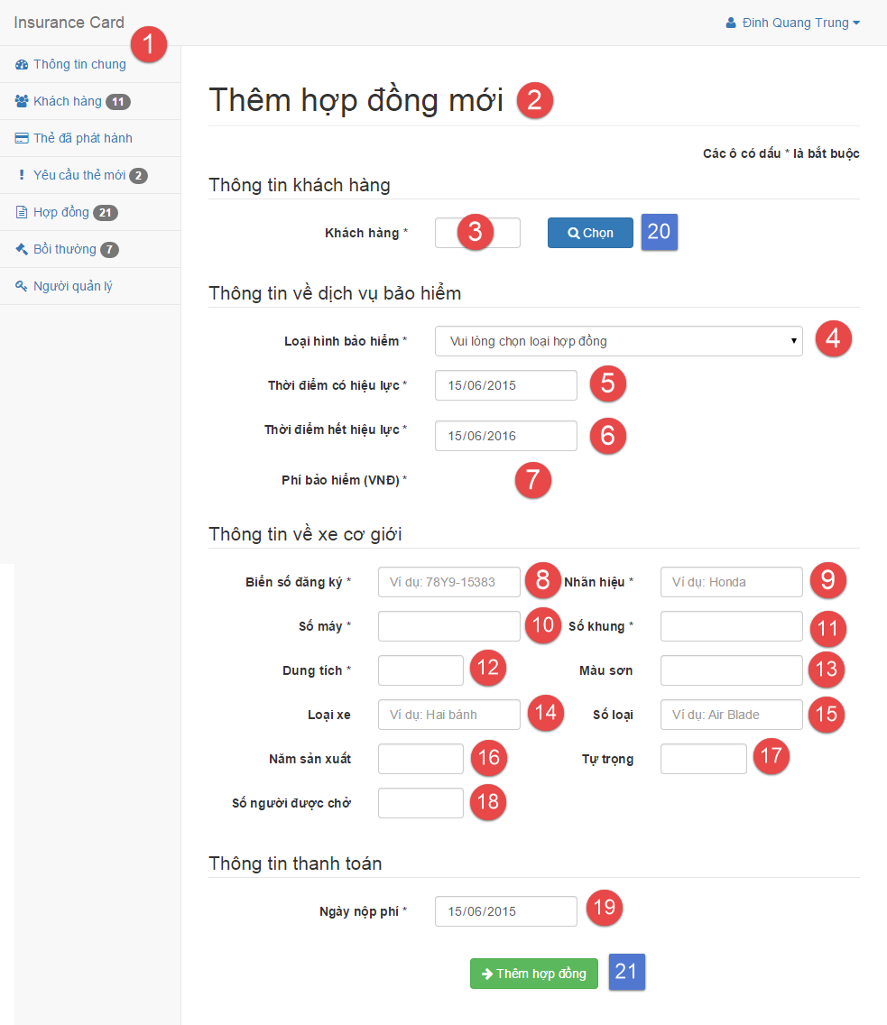

Figure Interface - <Staff> Create contract

**Fields**

|  |  |  |  |  |  |  |  |
| --- | --- | --- | --- | --- | --- | --- | --- |
| No | Field Name | Description | Read only | Mandatory | Control Type | Data Type | Length |
| 1 | Menu | Navigation bar | Yes | Yes | Menu bar | N/A | N/A |
| 2 | Title | Title of the page | Yes | Yes | Label | N/A | N/A |
| 3 | txtCustomerCode | Fill customer code | No | Yes | Textbox | String | 6 |
| 4 | ddlContractType | Select contract type | No | Yes | Select | N/A | N/A |
| 5 | txtStartDate | Select start date | No | Yes | Date input form | N/A | N/A |
| 6 | txtExpiredDate | Select expired date | No | Yes | Date input form | N/A | N/A |
| 7 | txtContractFee | Contract fee | Yes | Yes | Label | N/A | N/A |
| 8 | txtPlate | Fill vehicle plate | No | Yes | Textbox | String | 4 – 15 |
| 9 | txtBrand | Fill vehicle brand | No | Yes | Textbox | String | 2 – 20 |
| 10 | txtEngine | Fill vehicle engine | No | Yes | Textbox | String | 2 – 20 |
| 11 | txtChassis | Fill vehicle chassis | No | Yes | Textbox | String | 2 – 20 |
| 12 | txtCapacity | Fill vehicle capacity | No | Yes | Textbox | String | 2 – 20 |
| 13 | txtColor | Fill vehicle color | No | No | Textbox | String | 2 – 20 |
| 14 | txtType | Fill vehicle type | No | No | Textbox | String | 2 – 20 |
| 15 | txtModel code | Fill vehicle model code | No | No | Textbox | String | 2 – 20 |
| 16 | txtYearOfMan | Fill vehicle year of manufacture | No | No | Textbox | String | 4 |
| 17 | txtWeight | Fill vehicle empty weight | No | No | Textbox | String | 1 – 4 |
| 18 | txtSeatCapacity | Fill vehicle seat capacity | No | No | Textbox | String | 1 – 3 |
| 19 | txtPaidDate | Select paid contract fee date | No | Yes | Date input form | N/A | N/A |

Table <Staff> Create contract fields

**Buttons/Hyperlinks**

|  |  |  |  |  |
| --- | --- | --- | --- | --- |
| No | Function | Description | Validation | Outcome |
| 20 | btnSelect | Select customer | N/A | Transfer to select customer modal |
| 21 | btnCreate | Create new contract | N/A | Transfer to create new contract successful page |

Table <Staff> Create contract buttons/hyperlinks

##### Renew contract

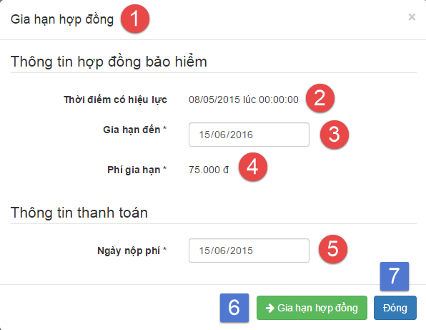

Figure Interface - <Staff> Renew contract

**Fields**

|  |  |  |  |  |  |  |  |
| --- | --- | --- | --- | --- | --- | --- | --- |
| No | Field Name | Description | Read only | Mandatory | Control Type | Data Type | Length |
| 1 | Title | Title of the modal | Yes | Yes | Label | N/A | N/A |
| 2 | Start date | Contract’s start date | Yes | Yes | Label | N/A | N/A |
| 3 | txtExpiredDate | Select expired date | No | Yes | Date input form | N/A | N/A |
| 4 | txtAmount | Renew contract fee | Yes | Yes | Label | N/A | N/A |
| 5 | txtPaidDate | Select paid contract fee date | No | Yes | Date input form | N/A | N/A |

Table <Staff> Renew contract fields

**Buttons/Hyperlinks**

|  |  |  |  |  |
| --- | --- | --- | --- | --- |
| No | Function | Description | Validation | Outcome |
| 6 | btnRenew | Renew contract | N/A | Transfer to renew contract successful page |
| 7 | btnClose | Close modal | N/A | Transfer to contract detail page |

Table <Staff> Renew contract buttons/hyperlinks

##### Cancel contract

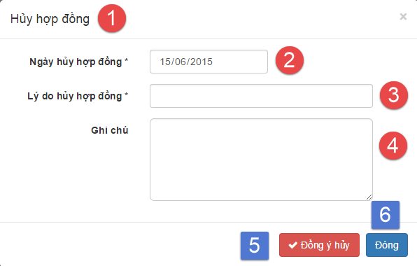

Figure Interface - <Staff> Cancel contract

**Fields**

|  |  |  |  |  |  |  |  |
| --- | --- | --- | --- | --- | --- | --- | --- |
| No | Field Name | Description | Read only | Mandatory | Control Type | Data Type | Length |
| 1 | Title | Title of the modal | Yes | Yes | Label | N/A | N/A |
| 2 | txtCancelDate | Select cancel contract date | No | Yes | Date input form | N/A | N/A |
| 3 | txtCancelReason | Fill cancel contract reason | No | Yes | Textbox | String | 1 – 250 |
| 4 | txtCancelNote | Fill note about cancel contract | No | No | Text area | String | 1 - 2000 |

Table <Staff> Cancel contract fields

**Buttons/Hyperlinks**

|  |  |  |  |  |
| --- | --- | --- | --- | --- |
| No | Function | Description | Validation | Outcome |
| 5 | btnCancel | Cancel contract | N/A | Transfer to cancel contract successful page |
| 6 | btnClose | Close modal | N/A | Transfer to contract detail page |

Table <Staff> Cancel contract buttons/hyperlinks

#### Customer Interface Design

##### Manage contract

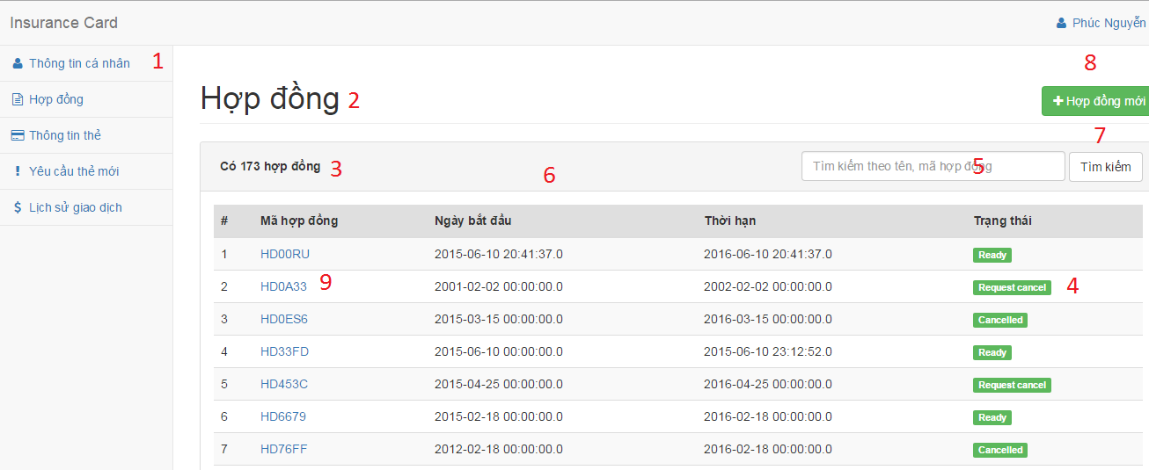

Figure Interface - <Customer> Manage contract

**Fields**

|  |  |  |  |  |  |  |  |
| --- | --- | --- | --- | --- | --- | --- | --- |
| No | Field Name | Description | Read only | Mandatory | Control Type | Data Type | Length |
| 1 | lblMenu | Navigation bar | Yes | Yes | Menu bar | N/A | N/A |
| 2 | lblTitle | Title of the page | Yes | Yes | Label | N/A | N/A |
| 3 | lblAmountContract | Number of available customer | Yes | No | Label | N/A | N/A |
| 4 | lblContractStatus | Status of contract | Yes | No | Label | N/A | N/A |
| 5 | txtSearch | Fill search keyword | No | Yes | Textbox | String | N/A |
| 6 | contractTable | Table of available contract | Yes | Yes | Table | N/A | N/A |

Table <Customer> Manage contract fields

**Buttons / Hyperlinks**

|  |  |  |  |  |
| --- | --- | --- | --- | --- |
| No | Function | Description | Validation | Outcome |
| 7 | btnSearch | Search by input keyword | N/A | Transfer to search result page |
| 8 | btnCreate | Create new customer | N/A | Transfer to create new customer page |
| 9 | linkContractDetail | View contract detail | N/A | Transfer to contract detail page |

Table <Customer> Manage contract buttons/hyperlinks

##### Contract detail

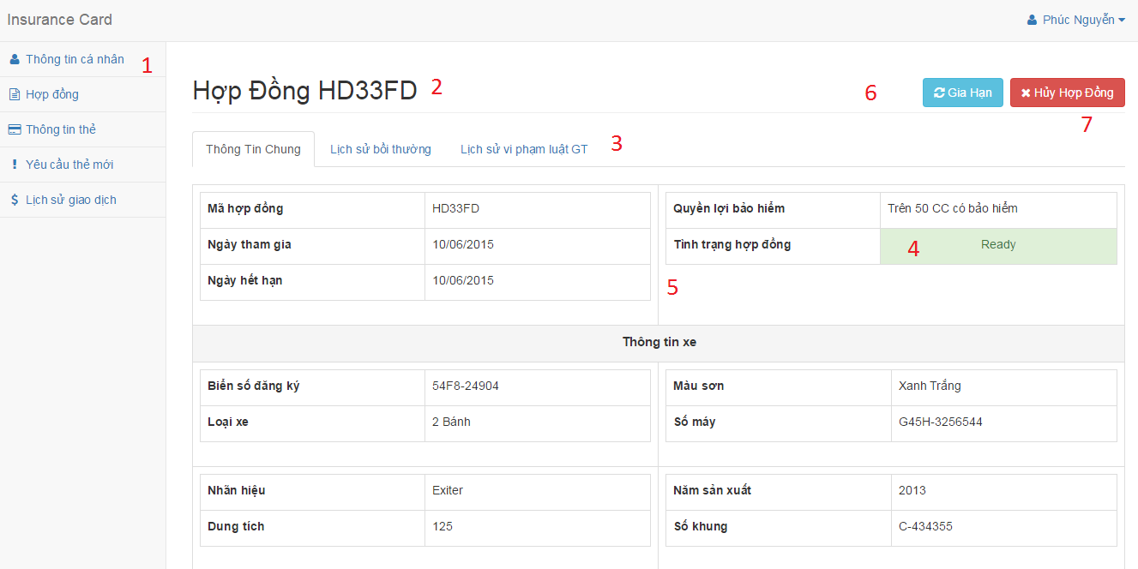

Figure Interface - <Customer> Contract detail

**Fields**

|  |  |  |  |  |  |  |  |
| --- | --- | --- | --- | --- | --- | --- | --- |
| No | Field Name | Description | Read only | Mandatory | Control Type | Data Type | Length |
| 1 | lblMenu | Navigation bar | Yes | Yes | Menu bar | N/A | N/A |
| 2 | lblTitle | Contract code | Yes | Yes | Label | N/A | N/A |
| 3 | txtTab | Information about contract | Yes | No | Tab | N/A | N/A |
| 4 | lblContractStatus | Status of contract | Yes | No | Label | N/A | N/A |
| 5 | txtInformation | Information about contract | No | Yes | Textbox | String | N/A |

Table <Customer> Contract detail fields

**Buttons / Hyperlinks**

|  |  |  |  |  |
| --- | --- | --- | --- | --- |
| No | Function | Description | Validation | Outcome |
| 6 | btnRenew | Renew contract | N/A | Show popup to choose the reason cancel |
| 7 | btnCancel | Cancel contract | N/A | Show popup to provide new time for contract and the way to pay for renew contract |

Table <Customer> Contract detail buttons/hyperlinks

##### Cancel contract

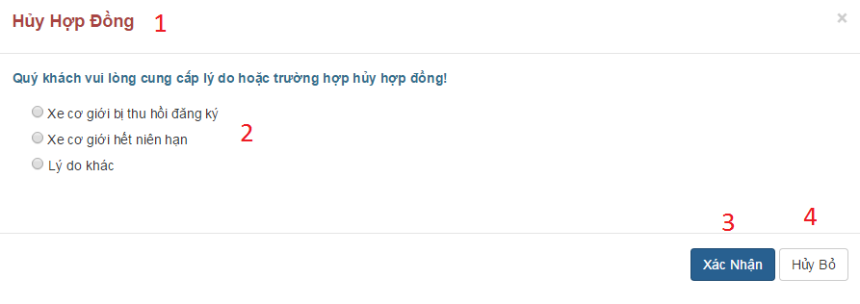

Figure Interface - <Customer> Cancel contract

**Fields**

|  |  |  |  |  |  |  |  |
| --- | --- | --- | --- | --- | --- | --- | --- |
| No | Field Name | Description | Read only | Mandatory | Control Type | Data Type | Length |
| 1 | lblTitle | Title | Yes | Yes | Label | N/A | N/A |

Table <Customer> Cancel contract fields

**Buttons / Hyperlinks**

|  |  |  |  |  |
| --- | --- | --- | --- | --- |
| No | Function | Description | Validation | Outcome |
| 2 | chkOptionCancel | Choose reason why customer cancel contract | N/A | N/A |
| 3 | btnConfirm | Confirm to cancel contract | If customer doesn’t input the reason in case they choose another reason, the system will notify. | Reload contract detail with information about contract is canceled |
| 4 | btnLeave | Leave request cancel | N/A | Return to contract detail |

Table <Customer> Cancel contract button/hyperlinks

##### Renew contract

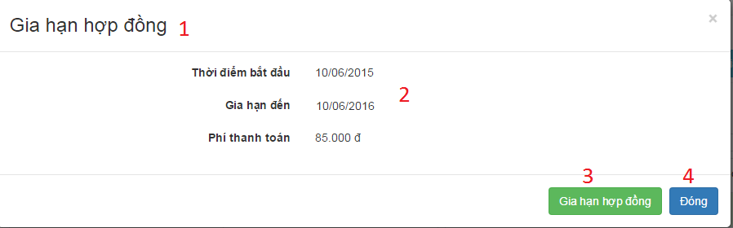

Figure Interface - <Customer> Renew contract

**Select paypment method**

**Fields**

|  |  |  |  |  |  |  |  |
| --- | --- | --- | --- | --- | --- | --- | --- |
| No | Field Name | Description | Read only | Mandatory | Control Type | Data Type | Length |
| 1 | lblTitle | Title | Yes | Yes | Label | N/A | N/A |
| 2 | txtInformation | Information about renew contract | Yes | Yes | Label | N/A | N/A |

Table <Customer> Renew contract fields

**Buttons / Hyperlinks**

|  |  |  |  |  |
| --- | --- | --- | --- | --- |
| No | Function | Description | Validation | Outcome |
| 3 | btnConfirm | Confirm to renew contract | N/A | Transfer to checkout page |
| 4 | btnLeave | Leave request renew | N/A | Return to contract detail |

Table <Customer> Renew contract button/hyperlinks

##### Select payment method

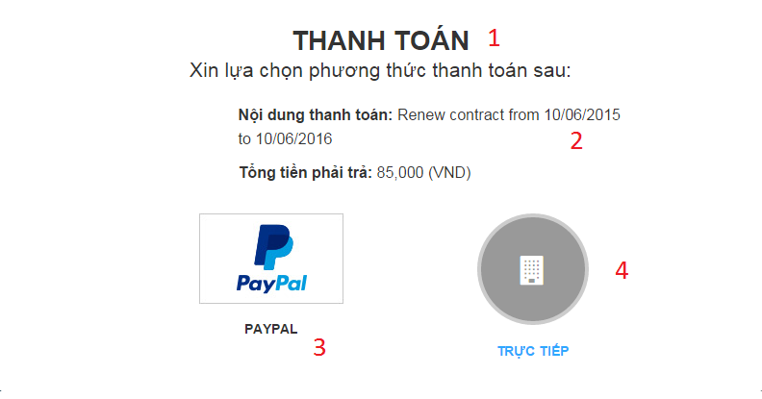

Figure Interface - <Customer> Select payment method

**Fields**

|  |  |  |  |  |  |  |  |
| --- | --- | --- | --- | --- | --- | --- | --- |
| No | Field Name | Description | Read only | Mandatory | Control Type | Data Type | Length |
| 1 | lblTitle | Title | Yes | Yes | Label | N/A | N/A |
| 2 | txtInformation | Information about renew contract | Yes | Yes | Label | N/A | N/A |

Table <Customer> Select payment method fields

**Buttons / Hyperlinks**

|  |  |  |  |  |
| --- | --- | --- | --- | --- |
| No | Function | Description | Validation | Outcome |
| 3 | btnPaypal | Payment by paypal | N/A | Transfer to paypal page |
| 4 | btnDirect | Payment direct at company | N/A | Show address of list company |

Table <Customer> Select payment method buttons/hyperlinks

**Select paypment method**

### Checker Mobile Application Design

#### Scan NFC card screen

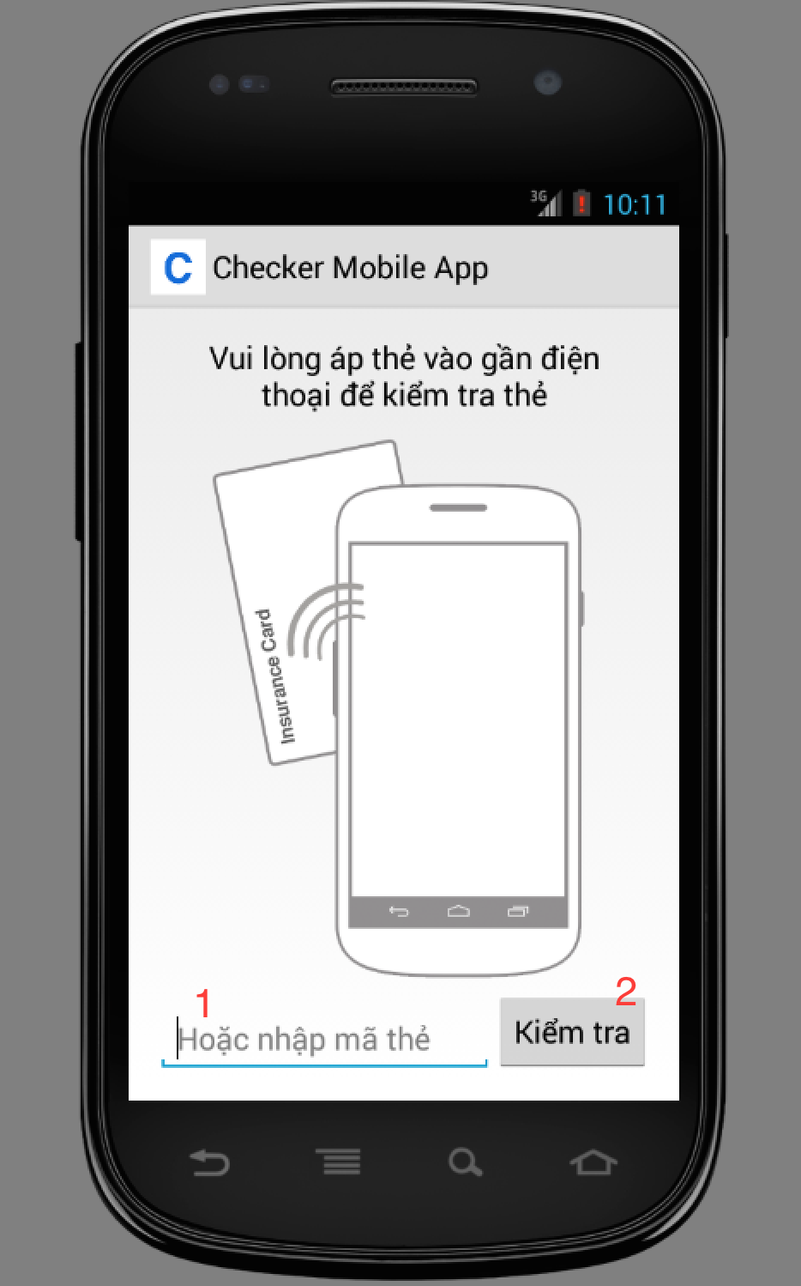

Figure Scan NFC card screen

**Fields**

|  |  |  |  |  |  |  |  |
| --- | --- | --- | --- | --- | --- | --- | --- |
| No | Field Name | Description | Read only | Mandatory | Control Type | Data Type | Length |
| 1 | txtCardIDnpen print card screen supporto view detail information of that contractCard | ID of the card | No | No | Textbox | String | 20 |

Table Scan NFC card screen - Fields

### Printer Mobile Application Design

#### Search contract screen

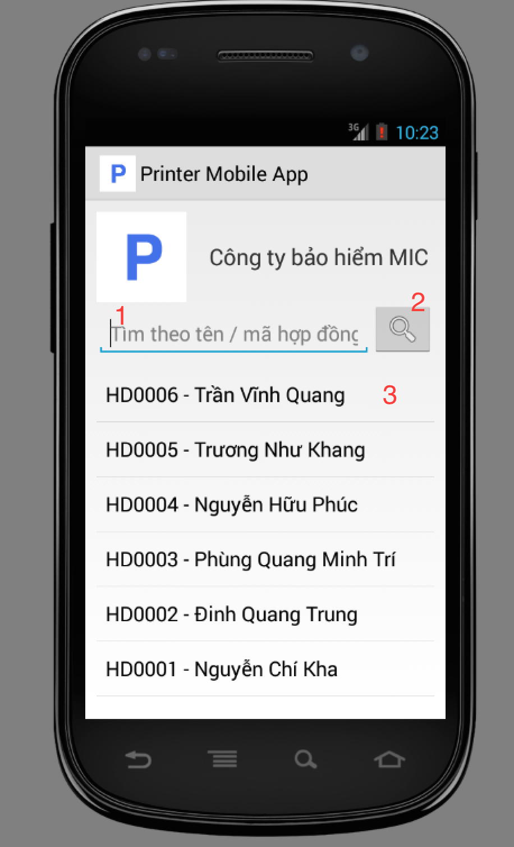

Figure Search contract screen

**Fields**

|  |  |  |  |  |  |  |  |
| --- | --- | --- | --- | --- | --- | --- | --- |
| No | Field Name | Description | Read only | Mandatory | Control Type | Data Type | Length |
| 1 | txtSearch | Search box where user input search keyword | No | No | Textbox | String | 0 - 200 |

Table Search contract screen - Fields

**Buttons**

|  |  |  |  |  |
| --- | --- | --- | --- | --- |
| No | Function | Description | Validation | Outcome |
| 2 | btnSearch | Search contract with keyword | N/A | The list will be updated with search results |
| 3 | lstContracts | Click to a row from the list to view detail information of that contract | N/A | Show view contract screen |

Table Search contract screen - Buttons

#### View contract screen

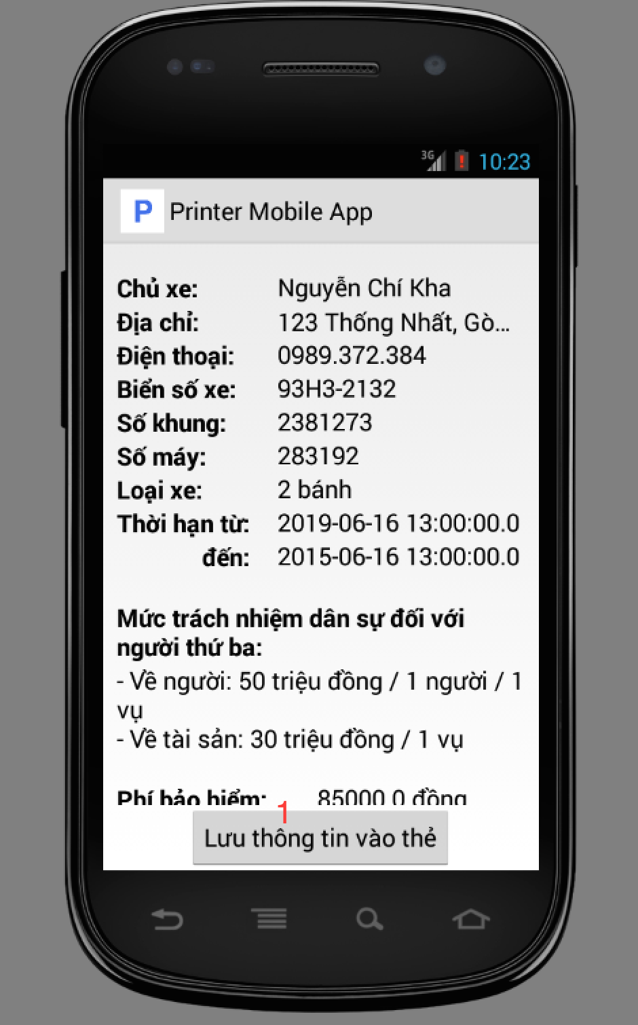

Figure View contract screen

**Buttons**

|  |  |  |  |  |
| --- | --- | --- | --- | --- |
| No | Function | Description | Validation | Outcome |
| 1 | btnPrint | Click to print information to NFC card | Phone have to have NFC support | Open print card screen |

Table View npen print card screen supporto view detail information of that contractcontract screen - Buttons

#### Print card screen

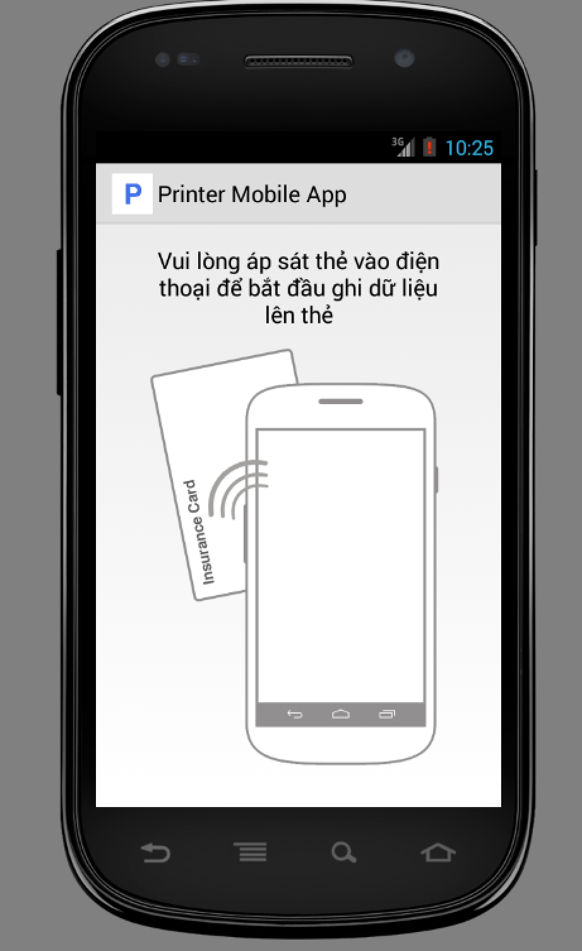

Figure Print card screen

## Database Design

### Entity relationship diagram